**Tic-Tac-Toe Endgame Data Set**

The dataset I used for this assignment can be found at:

<https://archive.ics.uci.edu/ml/datasets/Tic-Tac-Toe+Endgame>

This is a binary classification problem. This database encodes the complete set of possible board configurations at the end of tic-tac-toe games, where "x" is assumed to have played first. The target concept is "win for x" (i.e., true when "x" has one of 8 possible ways to create a "three-in-a-row").

**Results**

|  |  |  |
| --- | --- | --- |
| Algorithm accuracy | Bagging accuracy | AdaBoost accuracy |
| 65.34 % | 96.35 % | 96.45 % |

Both the Bagging and AdaBoost algorithms increased the accuracy *significantly*. With the algorithms, the model was able to predict the classification in almost every case. By sampling many different subsets of the data and taking an average for its predicted classification, the model is able to produce a much higher accuracy. This raw database gives a stripped-down decision tree algorithm fit, which is also why Bagging helped increase the accuracy.

**Extra Credit:**

Dow Jones Index Data Set: <https://archive.ics.uci.edu/ml/datasets/Dow+Jones+Index>

Results:

|  |  |  |
| --- | --- | --- |
| Algorithm accuracy | Bagging accuracy | AdaBoost accuracy |
| 2.93 % | 18.93 % | 4.13 % |

For this dataset, Bagging and AdaBoost increased the accuracy slightly. In either case, the accuracy was still far below any level of significance (much smaller than 50%). The accuracy of each individual tree alone was very poor (note the 2.93 % algorithm accuracy). By taking the average of many poor trees, the aggregated predictions (Bagging and AdaBoost) were not much better.

**Weka Outputs**

Algorithm Output (Tic-Tac-Toe)

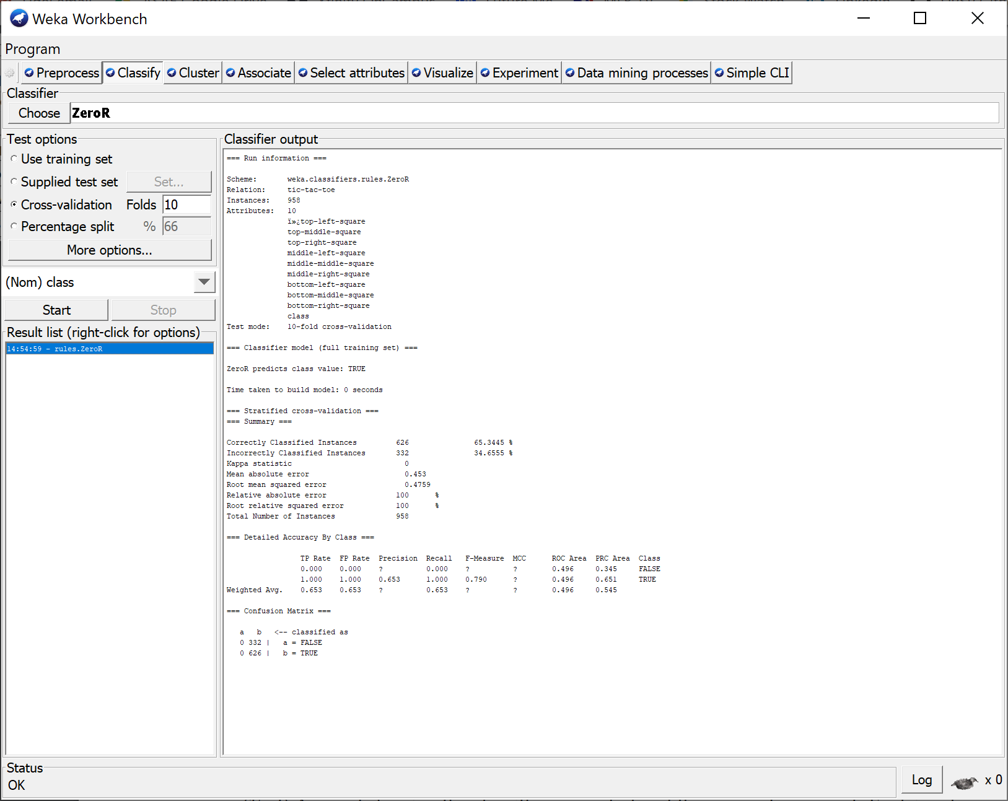

Bagging Output (Tic-Tac-Toe)

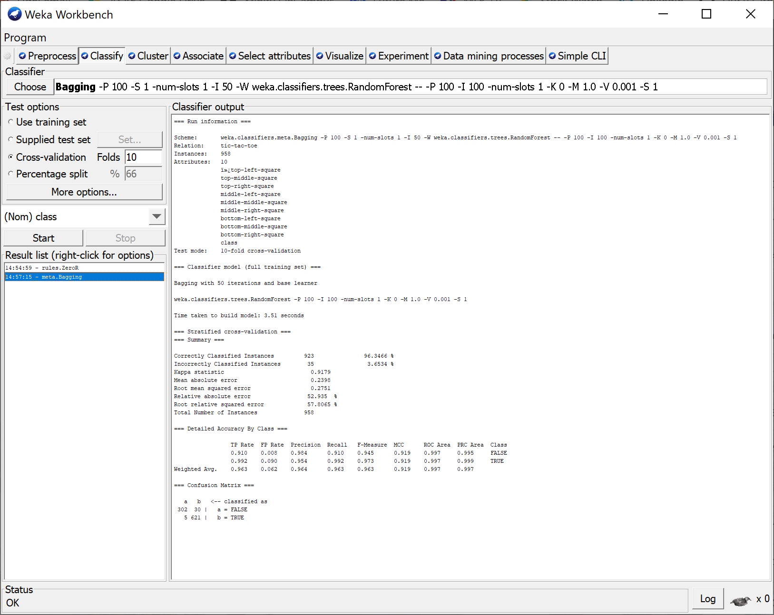

AdaBoost Output (Tic-Tac-Toe)

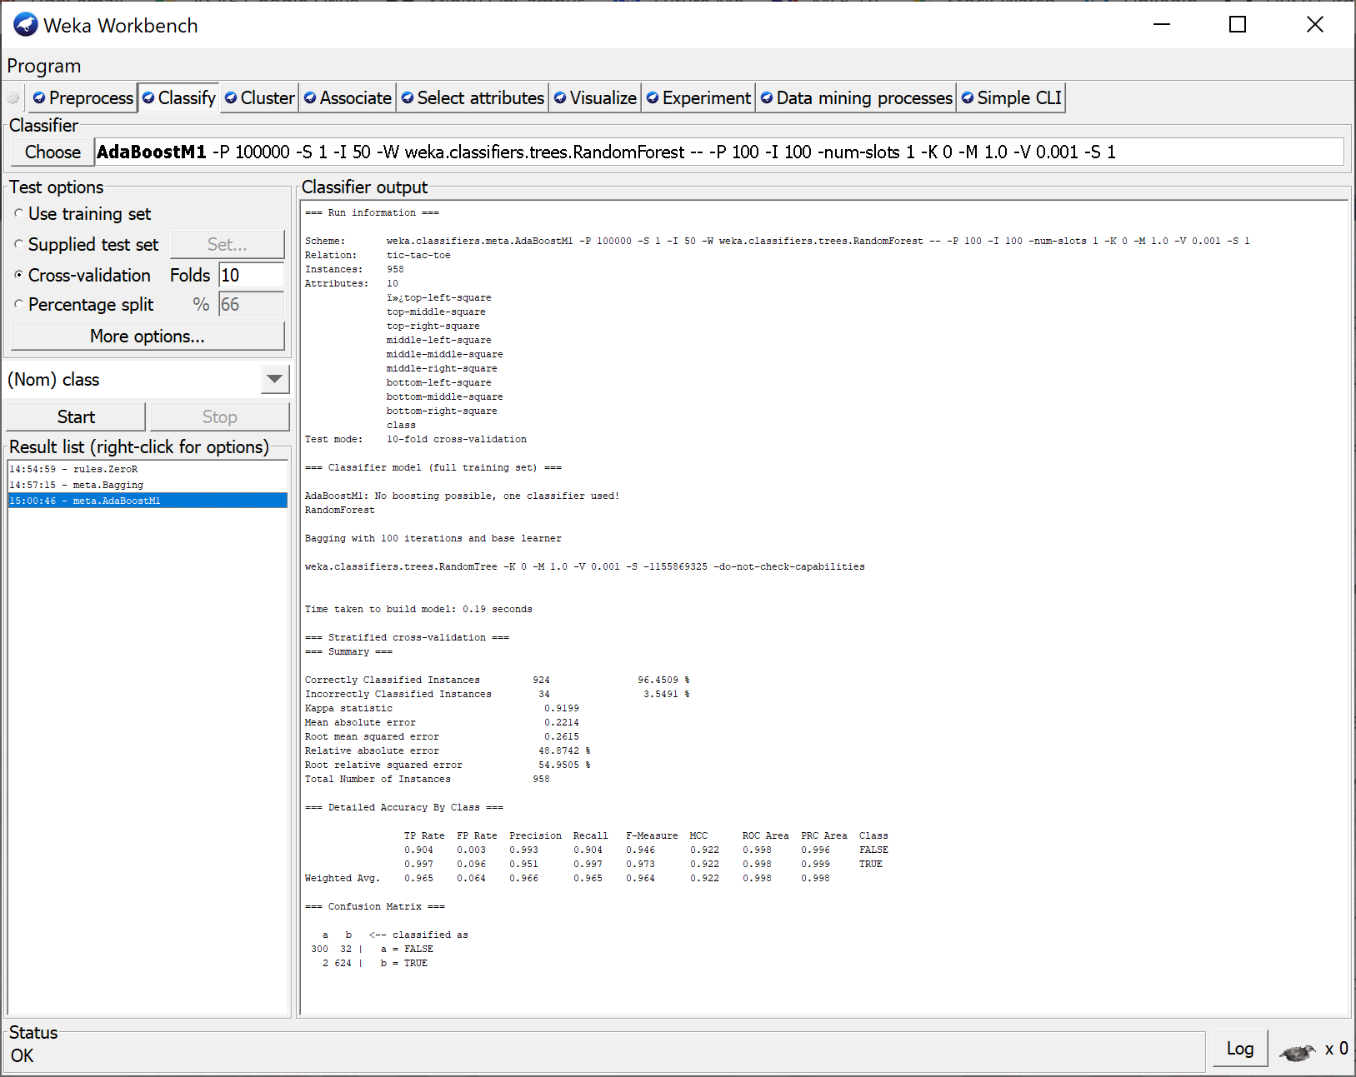

Algorithm Output (Dow Jones Index)

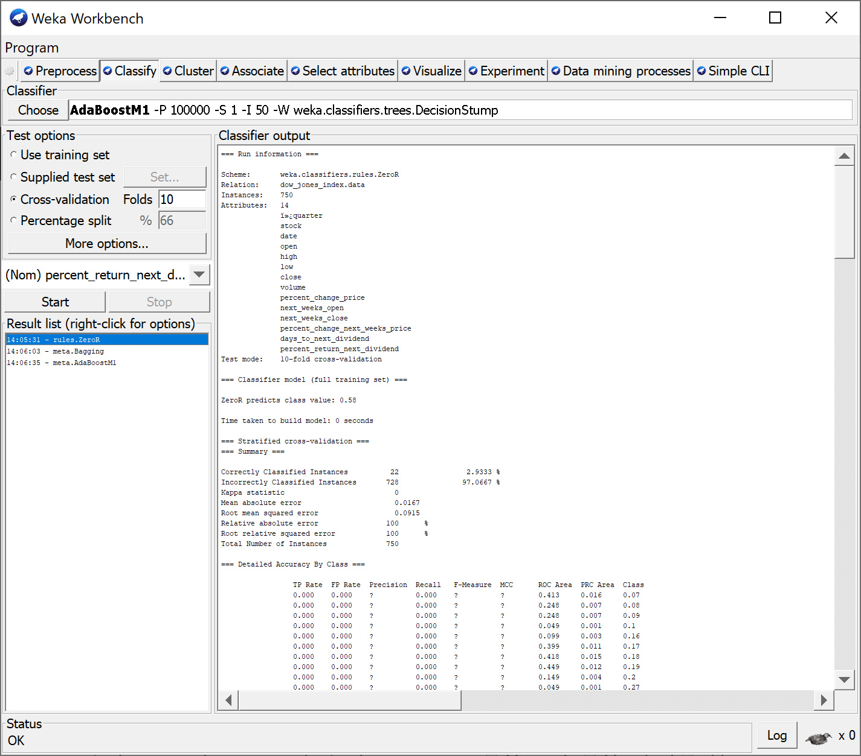



Bagging Output (Dow Jones Index)

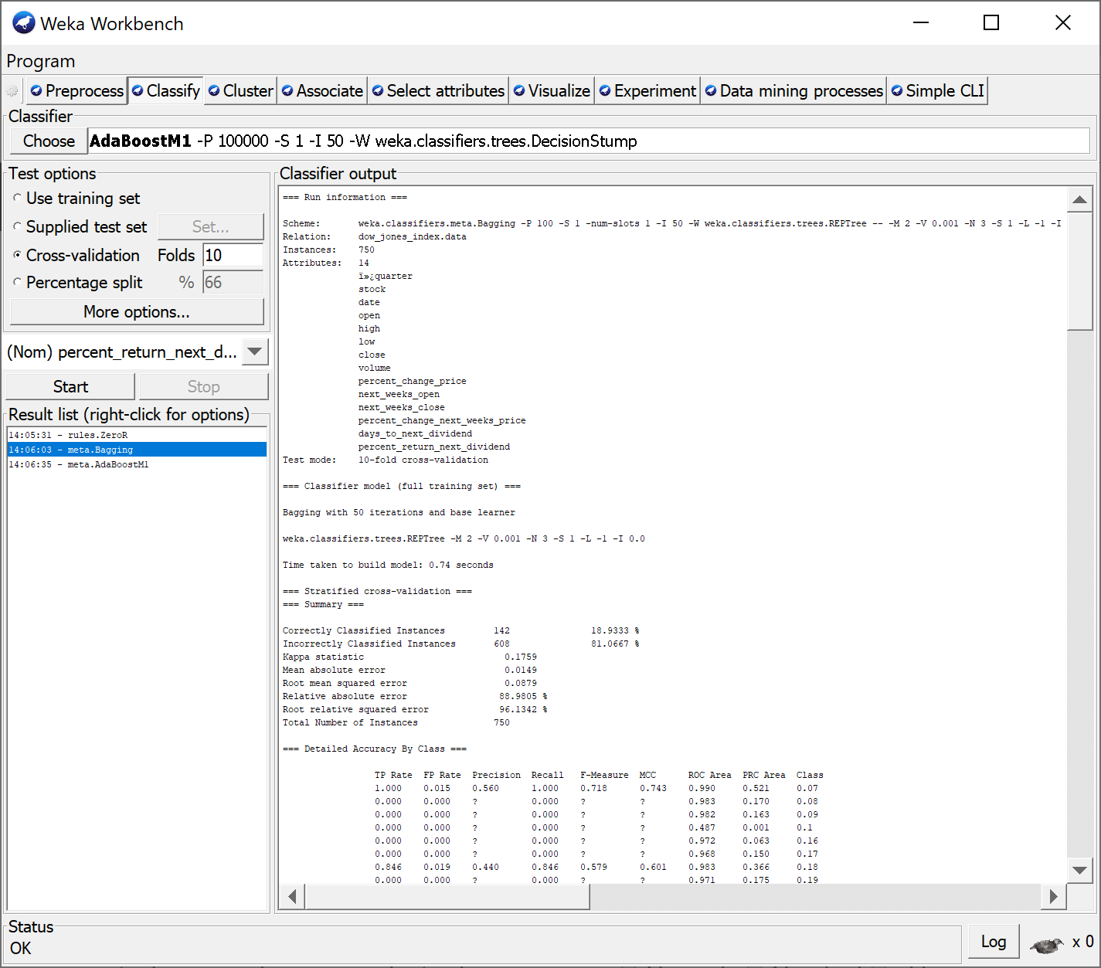



AdaBoost Output (Dow Jones Index)

